*Seethalakshmi achi college for women*

*Pallathur*

*Affiliate by alagappa university*

*Department of commerce*

*lll-B.COM*

***FINANCE AND ACCOUNTING WITH ZOHO***

***BOOKS***

***Team members are,***

***1.S.Jansirani.(team leader)***

***2.S.Jothilakshmi.***

***3.A.kalaiselvi.***

***4.K.kamali.***

***OVERVIEW:***

***Zoho books is an accounting solution that is designed to help small businesses manage their finances. This solution includes dashboards and a wide variety of reports . Business users can automate tasks and set up custom workflows.***

***The vendor offers a 14 days free trial.***

*Zoho books is online accounting software that manages your finances, keeps you* ***GST*** *compliant, automates business workflows, and helps you work collectively across departments.*

*Zoho books is a smart accounting system designed for growing businesses. It is very simple, easy to use, and able to help you make intelligent data-based divisions. It is also the pioneer accounting product of a reputed software provider, which eliminates all worries related to uptime ,support , or security.*

*With zoho books , you can send professional invoices to customers and begin receiving online payments from them all from a single platform. Its fact, powerful , at convenient,*

*and helps regain control over the company's finances and save more in the future.*

***EMPATHYMAP:****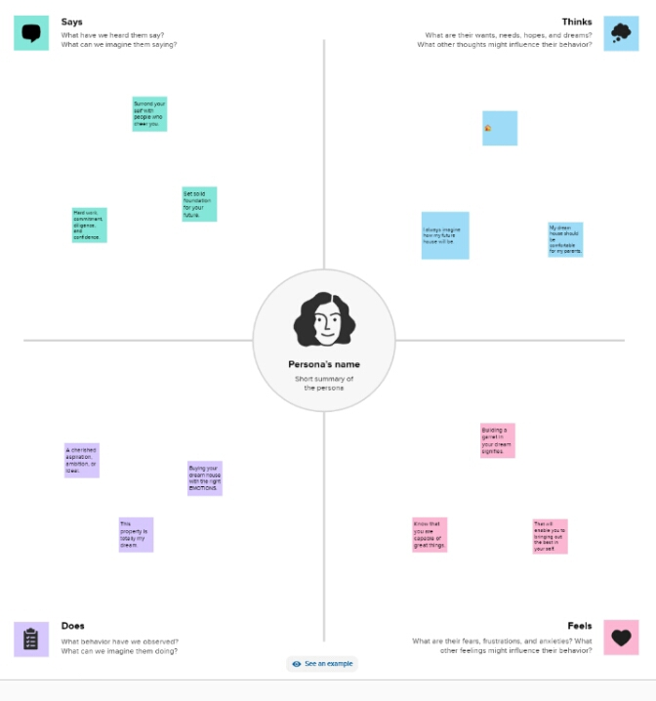*

***BRAINSTORMING AND IDEA PRIORITATION:***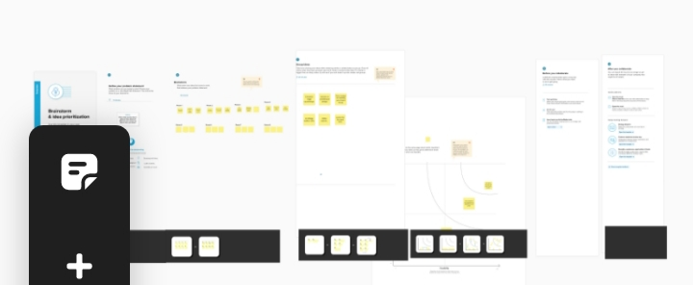

***RESULT:***

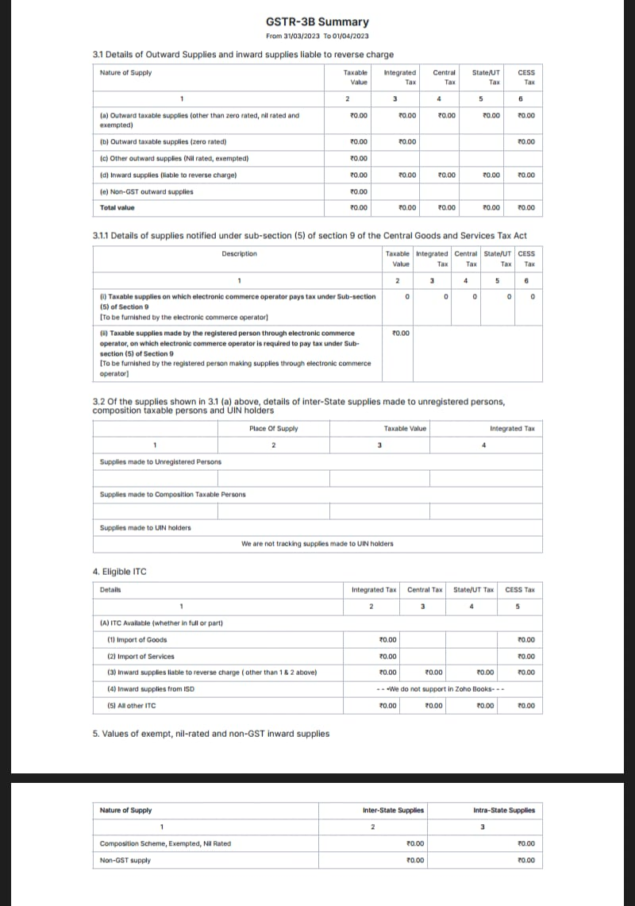

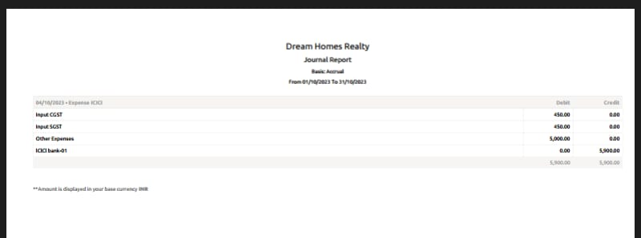

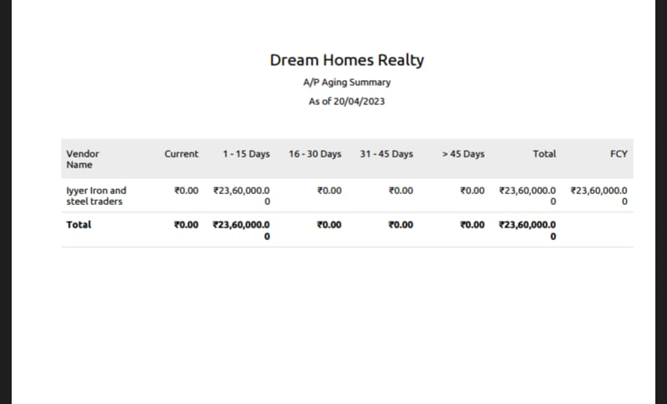

***ADVANTAGES OF THE PROPOSED SOLUTION:***

* ***Invoice and billing .***
* ***Online payment.***
* ***Report generations .***
* ***Reduce overall cost.***

***Expenses tracking.***

***DiSADVANTAGES OF THE PROPOSED SOLUTION:***

*@ monthly transaction cap. One significant zoho book limitation is the cap on monthly transaction.*

*@ multiple subscription for multiple busines.*

*@ no payroll services.*

*@ accounts transaction available.*

***THE AREAS WHERE THIS SOLUTION CAN***

*Zoho creators education* ***ERP*** *system has everting you need to completely run an educational institution, from preschool allatha way up to university . A custom school ERP built atop creators intuitive low-cost application development platform is a one-stop for all your education management needs.*

*From admission to accounting , take care of everything with cloud based applications.*

*Contact management online payments.inventory management expenses. Mobile apps.*

***CONCLUSIONS:***

***Zoho books*** *not only helps streamline our binvoicing, expencescand other business needs, but also simplifies accounting needs , to a greater extent. One c5even file GST return from within it which is a great add on features for free .above all , the support*

***FUTURE SCOPE:***

***Zoho books*** *now support recurring payments through stripe. You can receive recurring payments from your customers with payments care issued in India by either Visa or Mastercard. However, your customers card details will be saved only if they choose to save their cards while making payments.*